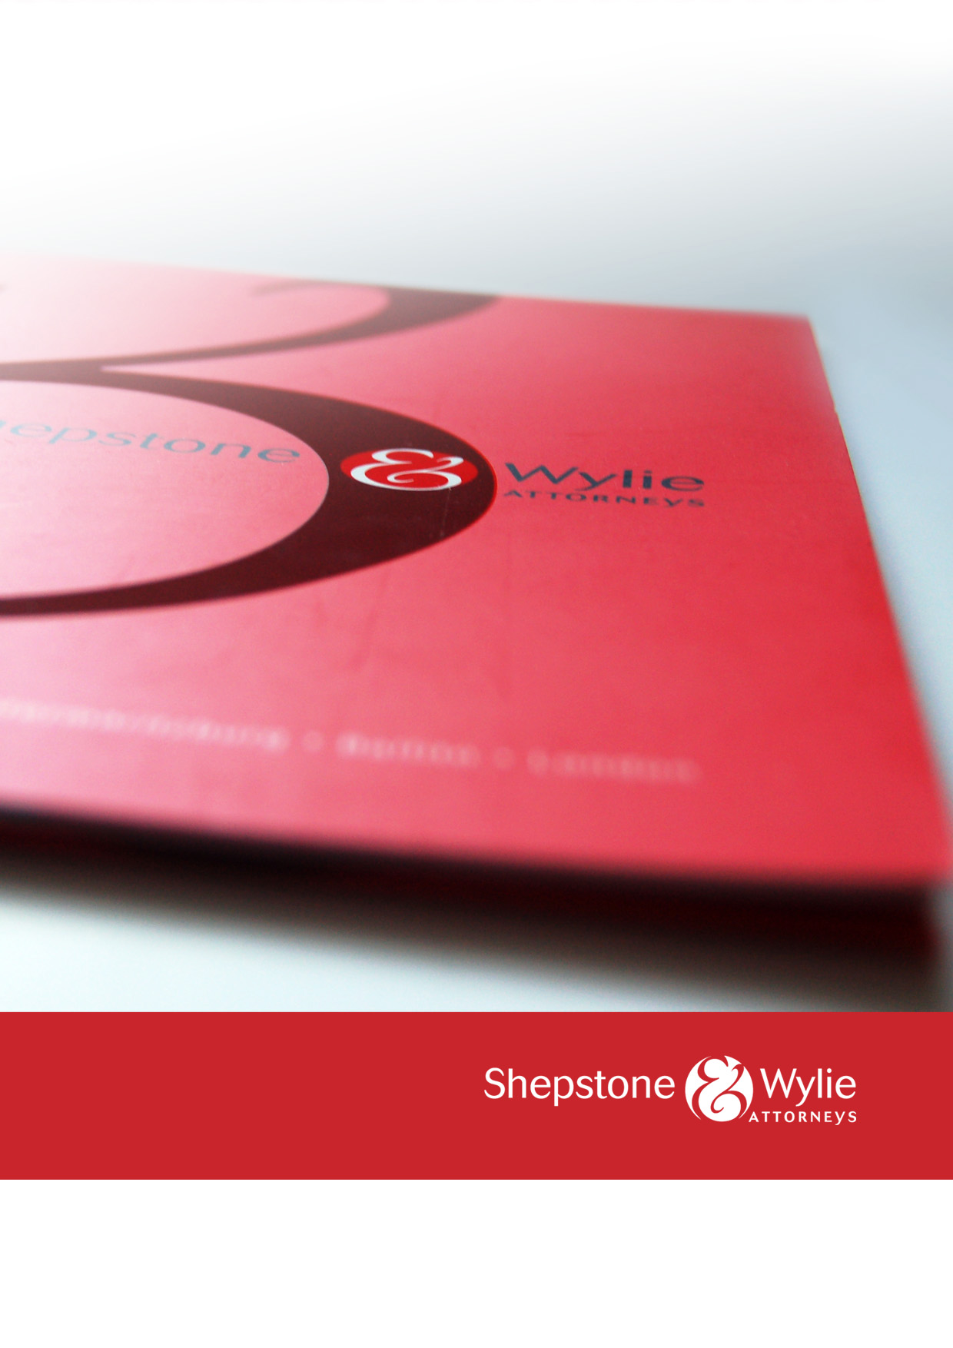

SHEPSTONE & WYLIE
PROFILE

INTRODUCTION

With the accumulated knowledge from over 45 partners around the country, Shepstone & Wylie offers a comprehensive range of legal services. We are proud of our heritage dating back to 1892. We operate across the country, with offices in Durban, Johannesburg, Cape Town, Richards Bay and Pietermaritzburg.

Shepstone & Wylie’s legal expertise include:

- Banking & Finance | - B-BBEE
- Business Rescue & Insolvency | - Child & Family
- Clean Energy | - Competition
- Construction & Engineering | - Corporate & Commercial
- Customs, Excise, Vat & Trade Remedies | - Employment
- Environmental | - Immigration
- Insurance | - Shipping & Logistics
- Litigation | - Mining & Minerals
- Pensions | - Planning & Development
- Property & Conveyancing | - Protection of Personal Information
- Social Media | - Tax

INDUSTRY RECOGNITION FOR SHEPSTONE & WYLIE
Shepstone & Wylie has recently received the following awards:

- PMR Diamond Arrow Award, top Large Law Firm in SA 2021
- PMR Golden Arrow Award, Law Firms in KZN 2020
- PMR Diamond Arrow Award, top Large Law Firm in SA 2020
- PMR Diamond Arrow Award, top Legal firm in KZN 2019
- PMR Golden Arrow Award, Large Law Firm in SA 2019
- PMR Diamond Arrow Award, top Legal firm in KZN 2018
- PMR Top Medium Size Legal Firm 2017
- Legal Week: African Legal Awards Litigation Team of the Year 2016
- 2015 KZN Top Business Award and Financial Business Services Award (short-listed in 2016); and
- African Law Digest Managing Partner of the Year 2016 finalist.

WHO WE ACT FOR
We act for a wide range of multi-nationals and national companies (some listed on the JSE Ltd or other recognised stock exchanges), financial institutions, local authorities, NGOs, educational institutions, property developers and private individuals from various industries, including pharmaceutical, pulp and paper, chemicals, fertilizers, cement, sugar, motor vehicles, steel, minerals and mining, energy, oil and gas, real estate, shipping, transport, construction, water, processed foods, consumer goods, retail, banking, finance and education.

The firm has worked with the following companies:

- ABSA Bank Ltd & ABSA Corporate Bank | - Albaraka Bank
- Bidfreight Port Operations | - Camargue
- Chep South Africa | - Dube Tradeport
- Eskom | - Grindrod Bank
- Haw & Inglis Engineering | - ICASA
- Illovo Sugar | - Investec Bank
- K Line Shipping | - MSC Shipping
- Massmart/Walmart | - Mondi Ltd
- National Bioproducts Institute | - Nedbank Corporate, Nedbank Private Wealth
- PRASA | - Private Property
- Richards Bay Minerals | - SA Home Loans
- Samsung | - SANRAL
- Sappi | - Shell International
- Shree Property Group | - Skema Holdings
- South Africa Sugar Association | - Standard Bank Business Banking
- Tiger Consumer Brands | - Tongaat Hulett
- Toyota South African Motors | - Unilever South Africa

MANAGING PARTNER

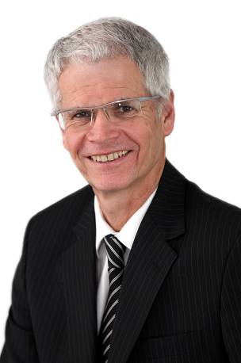 | NIGEL WOODROFFE  Qualifications: BA, LLB  Position in Firm: Managing Partner  Specialisations and Interests: Nigel Woodroffe joined the partnership in 1989 and headed the Employment Law department for several years before he was elected as Managing Partner of Shepstone & Wylie in July 2005.  This decision was taken since there had been tremendous growth in the business, and it had become increasingly difficult to manage the firm efficiently without a Managing Partner.

CUSTOMS TEAM
Customs @ Wylie is an initiative of the Shipping & Logistics Department and addresses the entire spectrum of technical Customs, Excise and VAT related issues. The focus is on simplifying the relations with Customs to save our clients’ money, whilst at the same time ensuring they comply with Customs legislation. Customs @ Wylie can see any dispute through to litigation where necessary. As part of a legal firm, any correspondence or documentation obtained from clients, or produced with a view to potential litigation, will be subject to legal privilege and does not have to be disclosed to SARS.

QUINTUS VAN DER MERWE
Qualifications: BCom, LLB (University of the Witwatersrand)
Position in Firm: Partner (Durban)
Specialisations and Interests: Quintus specialises in maritime and international trade law, including international sale contracts, logistics and warehousing, contracts of affreightment, charter parties and general admiralty work.

Quintus is a leading lawyer in the field of customs and excise and heads up the Shepstone & Wylie Customs team. He acts for a wide spectrum of clients across the supply chain, including an array of manufacturers, large retailers, importers, exporters, brokers, clearing and forwarding companies, shipping lines, road hauliers, warehouseman, liquid bulk storage facilities, diesel rebate users, chandelling industry, container depots and customs consultants. He also represents a number of industry associations. He is regularly involved in litigation for his clients.
Service on Boards and Associations: Quintus is an associated member of The South African Ship Suppliers Association, The Institute of Chartered Shipbrokers and The Maritime Lawyers Association (MLA).
FREEK VAN ROOYEN
Qualifications: Bluris (University of Port Elizabeth) LLB (UNISA) (Import and Export Law) (University of the North West)
Position in Firm: Partner (Johannesburg)
Specialisations and Interests: Freek has acted as counsel and attorney in major commercial and administrative litigation matters on behalf of both public entities and companies in inter alia the mining and financial sectors. Freek also focuses on customs and excise law and international trade remedy work and is one of the leading attorneys in the country specialising in such areas.
Freek advises clients at all levels of the supply chain, including importers, exporters, clearing agents and manufacturers. Freek deals with all customs and excise issues including, tariff applications, transaction value applications and disputes, detailed submissions to SARS and, when so required, settling papers for High Court proceedings. Freek has extensive experience in advising clients in the chemical, motor component, electronic, liquor and petroleum industries on customs, excise and trade remedy issues.

TARYN HUNKIN

Qualifications: BCom, LLB (UNISA)

Position in Firm: Customs Consultant (Durban)

Specialisations and Interests: Taryn is a Customs Consultant based in our Durban Office. She was previously employed by a leading pre-shipment inspection company, where she dealt with inter alia tariff classification and valuation for exports to other countries. Taryn has been with the team since 2007, assisting in customs advice and administration.

NALINI MAHARAJ

Qualifications: LLB (University of Port Elizabeth)

Position in Firm: Senior Consultant (Johannesburg)

Specialisations and Interests: Nalini has practised as an attorney in the Eastern Cape, with specialisation in Litigation and Corporate Law. Thereafter she joined the Customs and Excise Division at SARS as a Legal Specialist. Nalini has represented SARS on various Committees and has extensive experience in illicit commodities (fuel, alcohol, tobacco and clothing and textile), customs and excise legislation, legal advice, and legal drafting, providing training and involvement in legislative and policy amendments and drafting. After serving the organisation for almost 12 years, she set up a Customs and Excise Consultancy practice prior to joining Shepstone & Wylie. Nalini served as a member on various dispute resolution forums within SARS as well as externally.
SIPHESIHLE NGUBANE

Qualifications: LLB (University of KwaZulu Natal)

Position in Firm: Candidate Attorney (Durban)

Specialisations and Interests: Siphesihle is a Candidate Attorney in the Shipping and Logistics department. He spent several years at SARS: Customs after studying law under the SARS learnership program. He was in the Tariff section and sat on the Customs National Appeal Committee.

ORATILE MASELWA

Position in Firm: Candidate Attorney

Qualifications: LLB (North-West University-Mafikeng Campus)

Specialisations and Interests:
Oratile has experience working in customs, under the chairperson of the Customs National Appeal Committee (CNAC) (SARS).

MONA APPALSAMY

Qualifications: LLB (University of South Africa)

Position in Firm: Candidate Attorney (Johannesburg)

Specialisations and Interests: Prior to joining Shepstone & Wylie Mona was the legal advisor of the SARS Customs legal team. She has experience in all aspects of Customs and Excise and assists clients with: All Customs and Excise matters including responses to SARS, applications for determinations and advising on compliance and dispute resolution processes, Customs Litigation and alternative dispute resolution processes.

INSURANCE COVER

Shepstone & Wylie has professional indemnity insurance cover of R500 million.

CORPORATE SOCIAL RESPONSIBILITY

We give resources and support to a number of projects, including The Association for the Aged (TAFTA), Wylie House, Community Chest, Durban Coastal & Mental Health, Meals on Wheels. All of the firm’s practitioners also fulfil their annual Law Society mandated pro bono hours.
- OFFICES OF SHEPSTONE AND WYLIE

DURBAN  24 Richefond Circle, Ridgeside Business Park, Umhlanga Rocks, Durban, 4319  P O Box 305, La Lucia 4153  Docex 91 Durban, 4000  Tel: +27 31 575 7000  Fax: +27 31 575 7001 | CAPE TOWN  10th Floor, 2 Long Street, Cape Town,  8001  P O Box 7452, Roggebaai, 8012  Docex 272 Cape Town, 8001  Tel: +27 21 419 6495  Fax: +27 21 418 1974
JOHANNESBURG  Ground Floor, The Lodge, 38 Wierda Road West, Wierda Valley, Sandton, 2146  P.O. Box 2862, Saxonwold, 2132  Docex 12 Rosebank, 2196  Tel: + 27 11 290 2540  Fax: + 27 11 783 1301 | RICHARDS BAY  Suite 27 Calypso Centre, 2 Kruger Rand,  Richards Bay, 3900  P O Box 1705, Richards Bay, 3900  Docex 7 Richards Bay, 3900  Tel: +27 35 780 7250  Fax: +27 35 789 6404
PIETERMARITZBURG

15 Chatterton Road
ABSA House, 1ST Floor
Pietermaritzburg, 3201
PO Box 1368, Pietermaritzburg, 3200
Docex 97 Pietermaritzburg, 3200
Tel: +27 33 355 1780
Fax: +27 33 355 1799

