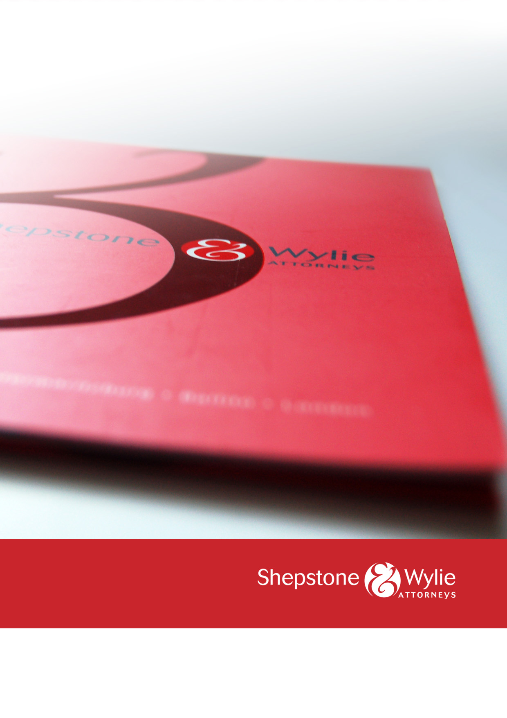

SHEPSTONE & WYLIE
PROFILE

INTRODUCTION

With the accumulated knowledge from over 45 partners around the country, Shepstone & Wylie offers a comprehensive range of legal services. We are proud of our heritage dating back to 1892. We operate across the country, with offices in Durban, Johannesburg, Cape Town, Richards Bay and Pietermaritzburg.

Shepstone & Wylie’s legal expertise include:

- Banking & Finance | - B-BBEE
- Business Rescue & Insolvency | - Child & Family
- Clean Energy | - Competition
- Construction & Engineering | - Corporate & Commercial
- Customs, Excise, Vat & Trade Remedies | - Employment
- Environmental | - Immigration
- Insurance | - Shipping & Logistics
- Litigation | - Mining & Minerals
- Pensions | - Planning & Development
- Property & Conveyancing | - Protection of Personal Information
- Social Media | - Tax

INDUSTRY RECOGNITION FOR SHEPSTONE & WYLIE
Shepstone & Wylie has recently received the following awards:

- PMR Diamond Arrow Award, top Large Law Firm in SA 2021
- PMR Golden Arrow Award, Law Firms in KZN 2020
- PMR Diamond Arrow Award, top Large Law Firm in SA 2020
- PMR Diamond Arrow Award, top Legal firm in KZN 2019
- PMR Golden Arrow Award, Large Law Firm in SA 2019
- PMR Diamond Arrow Award, top Legal firm in KZN 2018
- PMR Top Medium Size Legal Firm 2017
- Legal Week: African Legal Awards Litigation Team of the Year 2016
- 2015 KZN Top Business Award and Financial Business Services Award (short-listed in 2016); and
- African Law Digest Managing Partner of the Year 2016 finalist.

WHO WE ACT FOR
We act for a wide range of multi-nationals and national companies (some listed on the JSE Ltd or other recognised stock exchanges), financial institutions, local authorities, NGOs, educational institutions, property developers and private individuals from various industries, including pharmaceutical, pulp and paper, chemicals, fertilizers, cement, sugar, motor vehicles, steel, minerals and mining, energy, oil and gas, real estate, shipping, transport, construction, water, processed foods, consumer goods, retail, banking, finance and education.

The firm has worked with the following companies:

- ABSA Bank Ltd & ABSA Corporate Bank | - Albaraka Bank
- Bidfreight Port Operations | - Camargue
- Chep South Africa | - Dube Tradeport
- Eskom | - Grindrod Bank
- Haw & Inglis Engineering | - ICASA
- Illovo Sugar | - Investec Bank
- K Line Shipping | - MSC Shipping
- Massmart/Walmart | - Mondi Ltd
- National Bioproducts Institute | - Nedbank Corporate, Nedbank Private Wealth
- PRASA | - Private Property
- Richards Bay Minerals | - SA Home Loans
- Samsung | - SANRAL
- Sappi | - Shell International
- Shree Property Group | - Skema Holdings
- South Africa Sugar Association | - Standard Bank Business Banking
- Tiger Consumer Brands | - Tongaat Hulett
- Toyota South African Motors | - Unilever South Africa

MANAGING PARTNER

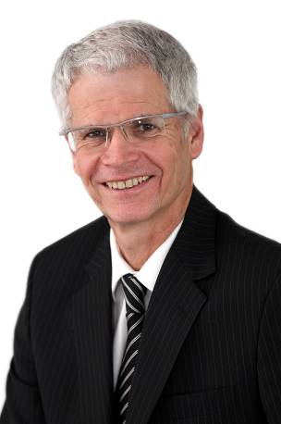 | NIGEL WOODROFFE  Qualifications: BA, LLB  Position in Firm: Managing Partner  Specialisations and Interests: Nigel Woodroffe joined the partnership in 1989 and headed the Employment Law department for several years before he was elected as Managing Partner of Shepstone & Wylie in July 2005.  This decision was taken since there had been tremendous growth in the business, and it had become increasingly difficult to manage the firm efficiently without a Managing Partner.

SHIPPING & LOGISTICS
QUINTUS VAN DER MERWE
Qualifications: BCom, LLB (University of the Witwatersrand)
Position in Firm: Head of Shipping & Logistics, Partner (Durban)

Specialisations and Interests: Quintus is Head of the Shipping & Logistics team and specialises in maritime and international trade law, including international sale contracts, logistics and warehousing, contracts of affreightment, charter parties and general admiralty work.
Quintus is a leading lawyer in the field of customs and excise and heads up the Shepstone & Wylie Customs team. He acts for a wide spectrum of clients across the supply chain, including an array of manufacturers, large retailers, importers, exporters, brokers, clearing and forwarding companies, shipping lines, road hauliers, warehouseman, liquid bulk storage facilities, diesel rebate users, chandelling industry, container depots and customs consultants. He also represents a number of industry associations. He is regularly involved in litigation for his clients.
Service on Boards and Associations: Quintus is an associated member of The South African Ship Suppliers Association, The Institute of Chartered Shipbrokers and The Maritime Lawyers Association (MLA).
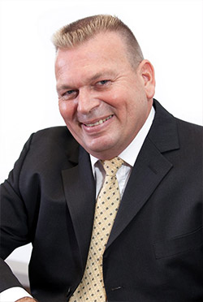 | TONY EDWARDS  Qualifications: LLB (University of South Africa)  Position in Firm: Partner (Durban)  Specialisations and Interests: Tony spent 4 years in the South African Navy and 18 years in the local maritime industry with the Rennies Group (now Bidfreight). He left Rennies in 2006 as Managing Director of marine surveyors, Rennie Murray & Co (Pty) Ltd. Tony served his articles of clerkship at Shepstone & Wylie under Shane Dwyer and was appointed as an associate in 2008, a senior associate in 2009 and a partner in 2010.  Tony specialises in admiralty litigation, in particular, the enforcement of maritime claims in South Africa and the arrest of property to obtain security for foreign proceedings, including by means of associated ship arrest and the arrest of bunkers and other maritime property. Tony has also been involved in a number of maritime casualties off the Southern African coast, and in numerous matters consequent to maritime casualties such as the procuring of access for surveyors and other experts and the preservation of evidence. He regularly attends on behalf of shipowners and their P&I Clubs, to the taking of statements and the procuring and preservation of evidence in matters involving crew, including cases of personal injury and death onboard ships.  Service on Boards and Associations: Tony is a member of the Shiparrested.com network and presented a paper at their annual conference in Antwerp in 2009. He is also a member of the Maritime Law Association of South Africa.
SHANE DWYER
Qualifications: BA (University of Stellenbosch), LLB (University of KwaZulu-Natal), Attorney of the Supreme Court of South Africa; Admitted Lesotho; Notary Public
Position in Firm: Consultant (Durban)

Specialisations and Interests: Shane is an experienced maritime and international trade lawyer who has practised in those disciplines for over 45 years. Shane deals with “wet work” (collisions, salvage, groundings and wreck removals), and has been involved in most major marine casualties on the Southern African coast (as far up as East Africa) over the past 45 years. Shane also deals with general admiralty claims and arrests, ship broking, non-contentious ship building contracts, charter parties, ship purchase, mortgages and financing contracts, air law and cross border international trade.
Service on Boards and Associations: Shane is a member of the Maritime Law Association (MLA) and a past member of their EXCO. He is also a member of the Chartered Institute of Ship Brokers and the International Bar Association (IBA) and is honorary member of Master Mariners Association. Shane has published numerous papers on maritime and air law in specialist publications. Shane was one of the contributing authors to the South African Chapter of the International Comparative Legal Guide to Shipping Law.
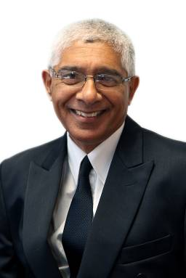 | KRISH REDDY  Qualifications: B.Proc (University of South Africa)  Position in Firm: Consultant (Durban)  Specialisations and Interests: Krish has extensive experience in all aspects of maritime law, including admiralty claims, cargo claims, salvage, collisions, oil pollution, charter party disputes, crew claims, disputes between ship owners and mortgagees, ship arrests and protection and indemnity related cases. Krish acts on behalf of international bunkering brokers and suppliers, and regularly represents the national Chinese fleet (COSCO) and many Indian, Indonesian, Greek and Italian shipping lines and P&I Clubs.
BRIAN MORKEL
Qualifications: BA, LLB (University of the Witwatersrand)
Position in Firm: Partner (Richards Bay)
Specialisations and Interests: Brian specialises in High Court and Magistrate’s Court litigation and financial recoveries.

ALLAN HEYDORN
Qualifications: BA, LLB, LLM specialising in Marine and Maritime Law (University of Cape Town), Conveyancer
Position in Firm: Partner (Richards Bay)
Specialisations and Interests: Allan runs a general litigation practice but has shifted his focus to maritime issues. He has been involved in various aspects of the law including access to the coastal zone, fishing rights, quota allocations, conservation, policy formulation, pollution, environmental and maritime law. He has held a skipper’s certificate and night rating since 1982 and has extensive knowledge of the marine environment. He also specialises in the administration of deceased estates, litigation involving estates and general conveyancing matters.
Service on Boards and Associations: Allan has also served on the Environmental sub-committee of the Zululand Chamber of Business, as a Commissioner of the Small Claims Court for ten years, as Honorary Secretary and Vice Commodore of the Zululand Yacht Club, founding member of the Sodwana Bay Spearfishing Club and since 2013 as Honorary Secretary of the Richards Bay branch of the Society of Master Mariners: South Africa.

PAULINE KUMLEHN

Qualifications: BA (cum laude) (University of KwaZulu-Natal), LLB (UNISA), LLM (UNISA)

Position in Firm: Partner (Cape Town)

Specialisations and Interests: Pauline is a Partner in Shipping & Logistics (including Customs @ Wylie) at Shepstone & Wylie’s Cape Town office. She specializes in maritime law and litigation as well as customs related work.
In relation to maritime law, she practices both “wet” and “dry” work relating to admiralty litigation, including the enforcement of maritime claims in South Africa, judicial sales and matters consequent to casualties (including access to and preservation of evidence).
Litigation experience includes high profile review applications relating to state owned entities and other government departments, including the Minister of Transport and the Department of Agriculture, Forestry and Fisheries.
Pauline also has experience in property transactions and financing, as well as commercial work. She has recently completed a Master of Laws (LLM) with distinction.
Pauline is an admitted Conveyancer and holds membership both with the Maritime Law Association of South Africa (MLA) and WISTA (South Africa).
WESLEY RAJBANSI

Qualifications: LLB (University of KwaZulu-Natal)

Position in Firm: Associate (Durban)

Specialisations and Interests: Wesley is an Associate in the Shipping and Logistics department with a special focus on maritime law and customs related disputes. He has experience in dealing with cargo/container stops by Customs and SAPS relating to parallel imports (lawful) and counterfeit goods (unlawful). Wesley also has experience with drafting relating to customs matters, contractual disputes and general litigation. He assists the partners with various shipping related activities, inclusive of drafting legal documents, handling cargo claims and ship arrests. Wesley is also a member of the Durban Chapter of the Maritime Law Association of South Africa.

LUCKY SITHOLE

Qualifications: LLB, Masters of Commerce in Maritime Studies (UKZN- Howard College), Marine Economy (Fujian Institute of Oceanography- China)

Position in Firm: Candidate Attorney (Durban)

Specialisations and Interests: Lucky has a Masters Qualification in maritime Law and Maritime Economics including; admiralty jurisdiction, carriage of goods by sea, customs and excise, analysis of sea freights markets, international business transactions in shipping, and ports economics.
Lucky has experience in Marine Law, Marine Economics and Marine Insurance Law. His work experience includes being the Legal & Commercial Junior Manager at Bidfreight Port Operations (Bidvest Head Office) and was responsible for shipping and logistics, Marine Insurance, Marine agencies- customs, drafting of legal documents, labour related matters, risk management, vessels onboard meetings, rate negotiations. Lucky has also worked at Dube TradePort Special Economic Zone (SEZ) and Property.
Lucky is currently pursuing Risk Management concerning different risks facing businesses at an advanced level.

INSURANCE COVER

Shepstone & Wylie has professional indemnity insurance cover of R500 million.

CORPORATE SOCIAL RESPONSIBILITY

We give resources and support to a number of projects, including The Association for the Aged (TAFTA), Wylie House, Community Chest, Durban Coastal & Mental Health, Meals on Wheels. All of the firm’s practitioners also fulfil their annual Law Society mandated pro bono hours.
- OFFICES OF SHEPSTONE AND WYLIE

DURBAN  24 Richefond Circle, Ridgeside Business Park, Umhlanga Rocks, Durban, 4319  P O Box 305, La Lucia 4153  Docex 91 Durban, 4000  Tel: +27 31 575 7000  Fax: +27 31 575 7001 | CAPE TOWN  10th Floor, 2 Long Street, Cape Town,  8001  P O Box 7452, Roggebaai, 8012  Docex 272 Cape Town, 8001  Tel: +27 21 419 6495  Fax: +27 21 418 1974
JOHANNESBURG  Ground Floor, The Lodge, 38 Wierda Road West, Wierda Valley, Sandton, 2146  P.O. Box 2862, Saxonwold, 2132  Docex 12 Rosebank, 2196  Tel: + 27 11 290 2540  Fax: + 27 11 783 1301 | RICHARDS BAY  Suite 27 Calypso Centre, 2 Kruger Rand,  Richards Bay, 3900  P O Box 1705, Richards Bay, 3900  Docex 7 Richards Bay, 3900  Tel: +27 35 780 7250  Fax: +27 35 789 6404
PIETERMARITZBURG

15 Chatterton Road
ABSA House, 1ST Floor
Pietermaritzburg, 3201
PO Box 1368, Pietermaritzburg, 3200
Docex 97 Pietermaritzburg, 3200
Tel: +27 33 355 1780
Fax: +27 33 355 1799

